|  |  |  |  |
| --- | --- | --- | --- |
| 1 | | 54,189.57142857143 | |
| NUMERO DE FRONTERAS | | ENERGIA AGREGADA | |
|  | | | |
| NO | | 0 | |
| CONTRATO | | VENCIMIENTO CONTRATO | |
|  | | | |
| 199,416,232 | 137 | | 7,371,830 |
| INGRESO 2019 | DÍAS CERTIFICADOS 2019 | | ENERGIA RESPALDADA 2019 |
|  | | | |
| 161,823,679 | 134 | | 5,972,257 |
| INGRESO 2020 | DÍAS CERTIFICADOS 2020 | | ENERGIA RESPALDADA 2020 |
|  | | | |
| 130,543,072 | 143 | | 5,690,285 |
| INGRESO 2021 | DÍAS CERTIFICADOS 2021 | | ENERGIA RESPALDADA 2021 |

|  |
| --- |
| **VIVA BARRANQUILLA**  USUARIO |

|  |
| --- |
| **Juan Marin**  Ejecutivo de cuenta |

|  |
| --- |
| **Carolina Bustamante / Líder de Operaciones VIVA / cbustamante@grupo-exito.com**  Primera fecha: PUNTO FOCAL |

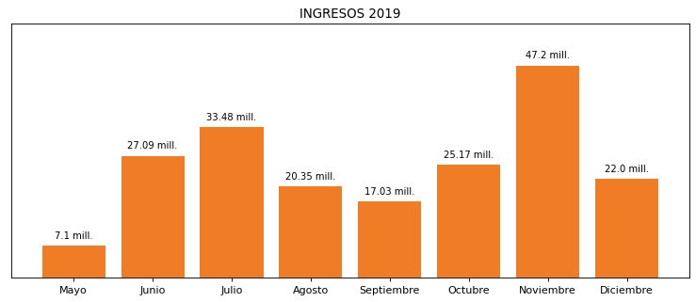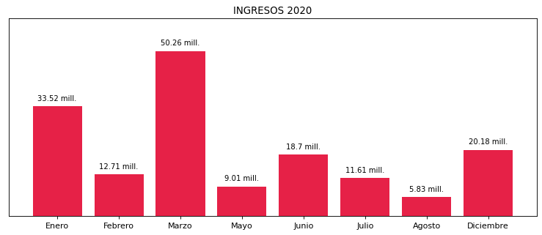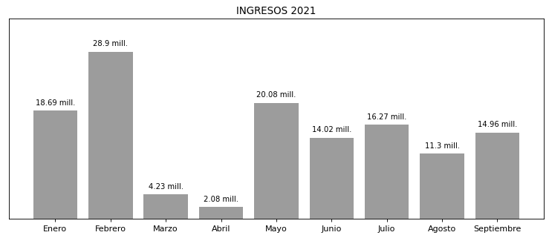

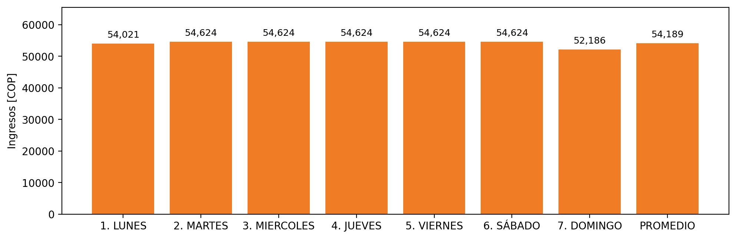

|  |  |  |  |  |  |  |  |  |  |
| --- | --- | --- | --- | --- | --- | --- | --- | --- | --- |
| **FRONTERA COMERCIAL** | **TIPO DDV** | **COD SIC** | **PREDIO** | **PROMEDIO** | **MARGEN** | **ÚLTIMA DESCONEXION** | **DÍAS CERTIFICADOS** | **ACTUALIZACION** | **PROXIMA PRUEBA DDV** |
| CENTRO COMERCIAL VIVA BARRANQUILLA | Frt32657 | Frt31139 | Prd01266 | 54,189 | 2,5 | 2021-11-02 | 0.0 | 2021-12-01 | 2022-02-25 |